

Minor Project

**Created By:**

Akanksha Kumari

BCA III

**Supervised By:**

Mrs. Anita Shah



FLOODHELPO

Flood Risk Management



**Introduction**

Flood risk management (FRM) aims to reduce the human and socio-economic losses caused by flooding while taking into account benefits from floods. Therefore, one important part of FRM is to analyse the relationships between the physical system, the institutional framework and socio-economic environment. This covers a wide range of topics from drivers and natural processes to models, decisions and socio-economic consequences and institutional environment. These manifold relationships and topics are not completely comprehensible for actors involved in flood risk management therefore, the knowledge of current theory and practice relating to flooding and flood management, as well as the knowledge of socio-economic issues related to flooding has to be visualized and made comprehensible. Such an integration of methods, models and data can be done by a flood risk management information system.

Disaster response is the second phase of the disaster Management cycle. It consists of a number of elements, for example, warning, evacuation, search and rescue, providing immediate assistance, assessing damage, continuing assistance and the immediate restoration. So, among all, I have worked upon a warning system for floods. In this, we have provided a user interface to the common public to check the level of water flow in rivers in future and have provided a mechanism of notification if there is any possibility of flood due to any river in nearby future (12 months). Along with that users can also see the historical trends of rivers flow and can visualize the rainfall patterns also in their Sub-Division (Area). So, with that much information beforehand and knowing the chances of the flood in any region we can prepare ourselves and alert the local public so that loss would be minimum.

**Objective**

The overall objective of FLOODHELPO is **to provide a pro-active and personalized citizen-centric public service application** that will encourage citizens’ involvement and will the involvement of the citizen and will harness the collaborative power of ICT [information and communication technology] networks (networks of people, knowledge and sensors) to raise awareness on flood risks and enable collective risk mitigation solutions and response actions.

The **general objectives of FLOODHELPO** are:

1. To provide support for the public authorities and government institutions’ hazard mitigation efforts, including planning and action coordination.
2. To inform the public on the risk exposure to natural hazards and how they can get prepared, respond, recover and mitigate the impacts of such events
3. To make use of the best available data in order to identify the location and potential impacts that natural hazards as floods can have on people, property and natural environment
4. To improve the systems of warning and emergency communications.
5. To empower local communities to directly participate in the design of emergency services dealing with mitigation actions for floods.
6. To harness the power of new technologies, such as social media and mobile technologies, to increase the efficiency of public administrations in raising public awareness and education regarding floods risks, effects and impact.

**Scope**

The Flood helpo set out a sustainable, long-term strategy to manage the flood risk within each River Basin, focused on the areas of potentially significant flood risk and the sources of flooding giving rise to that risk.

The scope of each Flood Risk Management Plan is:

* The Flood helpo set out the range of policies and measures, which are in place, under development or proposed that contribute to the reduction and management of flood risk throughout the River Basin.
* The Plans also set out viable measures, typically flood relief schemes, proposed to manage and reduce the flood risk in the communities that were identified as being at potentially significant flood risk.
* The measures set out in the Flood Plans address the sources of flooding identified as potentially significant in one or more communities within the area covered by each River Basin Plan.
* The Flood Plans set out the measures that are proposed as the most appropriate at this stage of assessment.

**PROJECT CATEGORY**

A database system is essentially a sophisticated, computerized record keeping system, a repository for a collection of computerized data files. A database system maintains information and makes that information available on demand, for this purpose a database system provides a set of facilities to perform such operations.

The most important advantage of the database is to maintain the integrity i.e. It ensures that the changes made to the database by authorized users do not result in a loss of data consistency and guard against user’s damage to the database.

**RDBMS have the following facilities:**

* Creation of files, Addition of data, Deletion of data, Modification of data.
* Retrieving the data collectively or selectively.
* The data stored can be sorted or indexed at users discretion or direction.
* Various reports can be produced from the system. These may either be standardized reports or that may be specifically generated according to specific user definition.
* Mathematical function can be performed and the data stored in the database can be manipulated with functions to perform the desired calculations.
* To maintain data integrity and database use.
* Data integrity for multiple users.

**MODULES**

Guidelines

Donation

Information Sharing

Weather Forecast

Emergency Service

**Hardware & Software Specification**

**Software requirement:**

**Operating System:** Window XP, 2003, 2007, 10

**Framework**: React.js

**Tools:** Mongodb Compass

**Front-End:** HTML5, CSS3, Bootstrap, JavaScript

**Back-End**: Express.js, Mongodb

**Server:** Node.js

**Browser:** Internet Explorer, Google Chrome, Mozilla Firefox etc.

**Hardware Requirement:**

**Monitor:** VDU

**Processor:** Intel Core i3 generation (speed 2GHZ or High)

**RAM:** 128 MB RAM

**HDD**: 20 GB HD CD-ROM

**DRIVE:** 52X

**SOFTWARE MODEL**

**1. HTML**

**HTML** stands for **Hypertext Mark-up Language**. It allows the user to create and structure sections, paragraphs, headings, links, and block-quotes for web pages and applications.

HTML is not a programming language, meaning it doesn’t have the ability to create dynamic functionality. Instead, it makes it possible to organize and format documents, similarly to Microsoft Word.

When working with HTML, we use simple code structures (tags and attributes) to mark up a website page.

Overall, HTML is a markup language that is really straightforward and easy to learn even for complete beginners in website building.

**2. CSS**

**C**ascading **S**tyle **S**heets, fondly referred to as CSS, is a simple design language intended to simplify the process of making web pages presentable.

CSS handles the look and feel part of a web page. Using CSS, you can control the color of the text, the style of fonts, the spacing between paragraphs, how columns are sized and laid out, what background images or colors are used, layout designs, variations in display for different devices and screen sizes as well as a variety of other effects.

CSS is easy to learn and understand but it provides powerful control over the presentation of an HTML document. Most commonly, CSS is combined with the markup languages HTML or XHTML.

**3. Bootstrap**

Bootstrap is the most popular HTML, CSS and JavaScript framework for developing a responsive and mobile friendly website. It is absolutely free to download and use.

* It is a front-end framework used for easier and faster web development.
* It includes HTML and CSS based design templates for typography, forms, buttons, tables, navigation, modals, image carousels and many others.
* It can also use JavaScript plug-ins.
* It facilitates you to create responsive designs.

**4. JavaScript**

JavaScript is a dynamic computer programming language. It is lightweight and most commonly used as a part of web pages, whose implementations allow client-side script to interact with the user and make dynamic pages. It is an interpreted programming language with object-oriented capabilities.

JavaScript was first known as **LiveScript,** but Netscape changed its name to JavaScript, possibly because of the excitement being generated by Java. JavaScript made its first appearance in Netscape 2.0 in 1995 with the name **LiveScript**. The general-purpose core of the language has been embedded in Netscape, Internet Explorer, and other web browsers.

**5.Node.js**

Node.js is a platform built on Chrome's JavaScript runtime for easily building fast and scalable network applications. Node.js uses an event-driven, non-blocking I/O model that makes it lightweight and efficient, perfect for data-intensive real-time applications that run across distributed devices.

Node.js is an open source, cross-platform runtime environment for developing server-side and networking applications. Node.js applications are written in JavaScript, and can be run within the Node.js runtime on OS X, Microsoft Windows, and Linux.

Node.js also provides a rich library of various JavaScript modules which simplifies the development of web applications using Node.js to a great extent.

**6.Express**

Express is a minimal and flexible Node.js web application framework that provides a robust set of features to develop web and mobile applications. It facilitates the rapid development of Node based Web applications. Following are some of the core features of Express framework −

* Allows to set up middleware’s to respond to HTTP Requests.
* Defines a routing table which is used to perform different actions based on HTTP Method and URL.
* Allows to dynamically render HTML Pages based on passing arguments to templates.

**7.React**

ReactJS is JavaScript library used for building reusable UI components. According to React official documentation, following is the definition− “React is a library for building composable user interfaces. It encourages the creation of reusable UI components, which present data that changes over time. Lots of people use React as the V in MVC. React abstracts away the DOM from you, offering a simpler programming model and better performance. React can also render on the server using Node, and it can power native apps using React Native. React implements one-way reactive data flow, which reduces the boilerplate and is easier to reason about than traditional data binding.”

**React Features**

* **JSX −** JSX is JavaScript syntax extension. It isn't necessary to use JSX in React development, but it is recommended.
* **Components −** React is all about components. You need to think of everything as a component. This will help you maintain the code when working on larger scale projects.
* **Unidirectional data flow and Flux −** React implements one-way data flow which makes it easy to reason about your app. Flux is a pattern that helps keeping your data unidirectional.
* **License −** React is licensed under the Facebook Inc. Documentation is licensed under CC BY 4.0.

**React Advantages**

* Uses virtual DOM which is a JavaScript object. This will improve apps performance, since JavaScript virtual DOM is faster than the regular DOM.
* Can be used on client and server side as well as with other frameworks.
* Component and data patterns improve readability, which helps to maintain larger apps.

**SRS DOCUMENT**

It is a reference document or contract between the customer and the development team. Once the customer agrees to the SRS document, the development team proceeds to develop the product conforming to all the requirements mentioned in the SRS document.

An SRS document should clearly document the following:

* **Functional requirements of the system:** Each function of the system can be considered as performing a transformation of a set of input data to the corresponding set of output data. The functional requirements of the system should clearly describe each of the functions that the system needs to perform along with the corresponding input and output data set.
* **Non-functional requirements of the system:** Non-functional requirements deal with the characteristics of the system that cannot be expressed functionally, e.g., maintainability, portability, Usability, etc. The non-functional requirements also include reliability issues, accuracy of results, human computer interface issues, operating and Physical constraints, etc.
* **Constraints on the system:** The constraints on the use of the system may describe certain things that the system should or should not do.

**Characteristic of SRS**

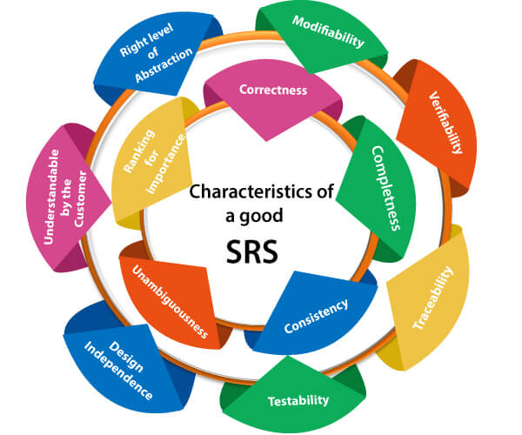

**Water Fall Model**

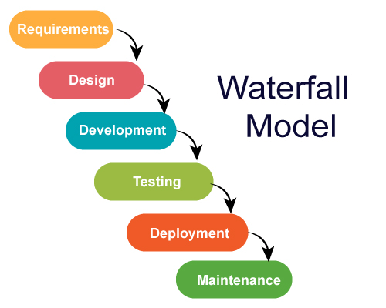The waterfall model is a sequential design process, used in software development processes, in which progress is seen as flowing steadily downwards (like a waterfall model) through the phases of Conception, Initiation, analysis, design, Construction, testing. Production implementation and maintenance.